**ajanta chemical industries**

812/E-11 INDUSTRIAL AREA, BHIWADI, PHASE-III

DISTRICT- ALWAR, RAJASTHAN - 301019 (INDIA)

TEL.:+91-1493-220247, 512266 FAX: +91-1493-220246,

E-mail: [ajanta@ajantacolours.com](mailto:ajanta@ajantacolours.com) Website : [www.ajantacolours.com](http://www.ajantacolours.com/)

## **PRODUCT SPECIFICATION**

**PRODUCT: VIOLET**

# DESCRIPTION : MIXTURE OF E122 + E133

**PHYSICAL APPEARANCE :** DARK REDDISH BLUE POWDER

**HUE IN WATER :** VIOLET

### SPECIFICATION

|  |  |  |  |
| --- | --- | --- | --- |
| **SR.NO.** | TEST |  | **LIMIT** |
| 1 | PURE DYE CONTENT, | MINIMUM | 85% |
| 2 | WATER INSOLUBLE MATTER, | MAXIMUM | 0.2% |
| 3 | ARSENIC | MAXIMUM | 3MG/KG |
| 4 | LEAD | MAXIMUM | 10MG/KG |
| 5 | HEAVY METALS ( as Pb) | MAXIMUM | 40MG/KG |

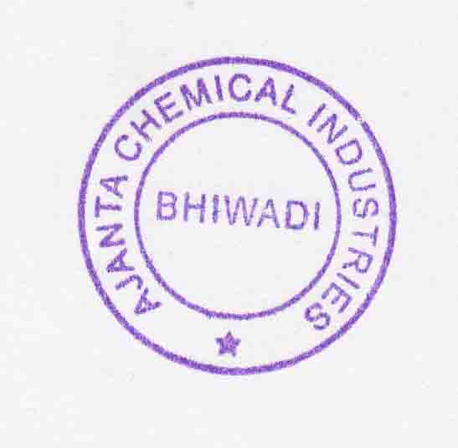

**SHELF LIFE : 3 YEARS**