ACI/BHD/2022-23 DATE: 24/11/2022
COLOUR SPECIFICATION “TARTRAZINE”
EEC No. : E 102

FD & C No. : Yellow 5
C.I. Name : Yellow 4
C.I. No. : 19140
Synonyms : Food Yellow 4
Einecs : 217-699-5
CAS No. : 1934-21-0
Chemical Formula : C₁₆H₉N₄Na₃O₉S₂
Chemical Name : Trisodium-5-hydroxy-1-(4-sulfonatophenyl)-4-(4-sulfonatophenylazo)-
H-pyrazole-3-carboxylate
Physical Appearance : Light Orange to Reddish Orange Powder / Granuals
Appearance of the Aqueous Solution : Yellow
Wavelength of Max. Absorbance : @426 nm
Absorptivity g.cm / 100ml : 530
Bulk Density (BD) : 60-80g/100ml

Pure Dye Content %( On Dry Basis at 105° C) : Not less than 87%
Loss on Drying At 135°C & Sodium Chloride / Sulfate : Less than 13%
Water Insoluble Matter : Less than 0.2%
Ether Extractable Matter : Less than 0.2%
Subsidiary Colouring Matters : Less than 1%
Organic Compounds other than colouring matters:
Sum of 4-Hydrazinobenzenesulfonic acid,
4-Aminobenzenesulfonic acid, 5-Oxo-1-(4-sulfophenyl)- Less than 0.5 %
2-pyrazoline-3-carboxylic acid, 4,4'-Diazoaminodi
(benzenesulfonic acid), Tetrahydroxysuccinic acid

Unsulfonated Primary Aromatic Amines : Less than 0.01 %
Lead (As “Pb”) : Less than 2 PPM
Arsenic (As “As”) : Less than 3 PPM
Mercury (As “Hg”) : Less than 1 PPM
Cadmium (As “Cd”) : Less than 1 PPM
Heavy Metals : Less than 40 PPM
Solubility : Soluble in water, sparingly soluble in ethanol.
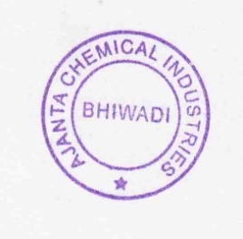
Identification of colouring matters : Passes test
Shelf Life : 3 Years
Storage Condition: Dry and cool place, avoid sun light & moisture
Note: Above Specification As Per EU Regulations No: 231/2012

