COLOUR SPECIFICATION “SUNSET YELLOW FCF”

EEC No. : E 110

FD & C No. : Yellow 6
C.I. Name : Yellow 3
C.I. No. : 15985
Synonyms : Food Yellow 3
Einecs : 220-491-7
CAS No. : 2783-94-0
Chemical Formula : C₁₆H₁₀N₂Na₂O₇S₂
Chemical Name : Disodium 2-hydroxy-1-(4-sulfonatophenylazo)naphthalene-6-sulfonate
Physical Appearance : Light Orange to Reddish Orange Powder
Appearance of the Aqueous Solution : Orange
Wavelength of Max. Absorbance : @485 nm
Absorptivity g.cm / 100ml : 555
Bulk Density (BD) : 60-80g/100ml

Pure Dye Content (On Dry Basis at 105⁰C) : Not less than 87%
Loss on Drying At 135⁰C & Sodium Chloride / Sulfate : Less than 13%
Water Insoluble Matter : Less than 0.2%
Ether Extractable Matter : Less than 0.2%
Subsidiary colouring matters : Less than 5%
1-(Phenylazo)-2-naphthalenol (Sudan I) : Less than 0.5 PPM

Organic Compounds other than colouring matters:
4-aminobenzene-1-sulfonic acid
3-hydroxynaphthalene-2,7-disulfonic acid
6-hydroxynaphthalene-2-sulfonic acid
7-hydroxynaphthalene-1,3-disulfonic acid Less than 0.5%
4,4’-diazoaminodi(benzene sulfonic acid)
6,6’-oxydi(naphthalene-2-sulfonic acid)

Unsulphonatic primary aromatic amines : Less than 0.01%
Lead (As “Pb”) : Less than 2 PPM
Arsenic (As “As”) : Less than 3 PPM
Mercury (As “Hg”) : Less than 1 PPM
Cadmium (As “Cd”) : Less than 1 PPM
Heavy Metals : Less than 40 PPM
Identification of colouring matters : Passes Test.
Solubility : Soluble in water, sparingly soluble in ethanol
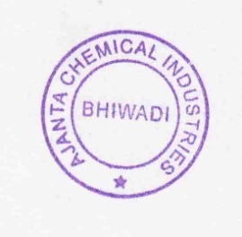
Shelf Life : 3 Years
Storage Condition: Dry and cool place, avoid sun light & moisture
Note: Above Specification As Per EU Regulations No: 231/2012

