COLOR SPECIFICATION “ERYTHROSINE”
EEC NO. : E-127
C.I. NAME : RED 14
C.I.NO. : 45430
Synonyms : Food Red 14
Einecs : 240-474-8
CAS No. : 16423-68-0
Chemical Formula : C₂₀H₆I₄Na₂O₅
Chemical Name : Disodium 2-(2,4,5,7-tetraiodo-3-oxido-6-oxoxanthen-9-yl)benzoate monohydrate
Physical Appearance : Red Powder or Granules.
Appearance of the Aqueous Solution : Red
Wavelength of Max. Absorbance : @526 nm
Absorptivity g.cm / 100ml : 1100
Bulk Density (BD) : 60-80g/100ml
DYE CONTENT% (ON DRY BASIS AT 105°C) : NOT LESS THAN 87% Loss on Drying at 135°C & Sodium Chloride / Sulfate : LESS THAN 13%
WATER INSOLUBLE MATTER : LESS THAN 0.20%
ETHER EXTRACTABLE MATTER : LESS THAN 0.20%
SUBSIDIARY COLOURING MATTERS : LESS THAN 4.00%
ORGANIC COMPOUNDS OTHER THAN COLOURING MATTERS:
Tri-iodoresorcinol : LESS THAN 0.2%
2-(2, 4-dihydroxy-3, 5-di-iodobenzoyl) benzoic acid : LESS THAN 0.2%
UNSULFONATED PRIMARY AROMATIC AMINES : LESS THAN 0.01 %
INORGANIC IODIDES : NOT MORE THAN 0.1%
LEAD (As “Pb”) : LESS THAN 2 PPM
ARSENIC (As “As”) : LESS THAN 1 PPM
MERCURY (As “Hg”) : LESS THAN 1 PPM
CADMIUM (As “Cd”) : LESS THAN 1 PPM
FLUORESCEIN : LESS THAN 20 PPM
ZINC (As “Zn”) : LESS THAN 50 PPM
HEAVY METALS : LESS THAN 40 PPM
SOLUBILITY : SOLUBLE IN WATER & IN ETHANOL
IDENTIFICATION OF COLOURING MATTERS : PASSES TEST
SHELF LIFE : 3 YEARS

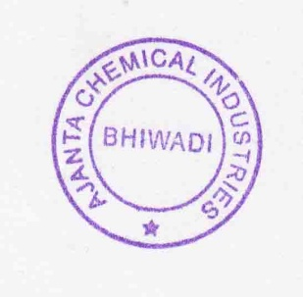
Storage Condition: Dry and cool place, avoid sun light & moisture
Note: Above Specification As Per EU Regulations No: 231/2012

