COLOUR SPECIFICATION “BRILLIANT BLUE”
EEC No. : E 133

FD & C No. : Blue 1
C.I. Name : Blue 2
C.I. No. : 42090
Synonyms : Food Blue 2
Einecs : 223-339-8
CAS No. : 3844-45-9
Chemical Formula : C₃₇H₃₄N₂Na₂O₉S₃
Chemical Name : Disodium α-(4-(N-ethyl-3-sulfonatobenzylamino) phenyl)-α-(4-N-ethyl-3-
sulfonatobenzylamino) cyclohexa-2,5-dienylidene) toluene-2-sulfonate
Physical Appearance : Reddish Shinning Blue Powder
Appearance of the Aqueous Solution : Blue
Wavelength of Max. Absorbance : @630 nm
Absorptivity g.cm / 100ml : 630
Bulk Density (BD) : 60-80g/100ml

Pure Dye Content % (On Dry Basis at 105°C) : Not less than 87%
Loss on Drying at 135°C & Sodium Chloride / Sulfate : Less than 13%
Water Insoluble Matter : Less than 0.2%
Ether Extractable Matter : Less than 0.2%
Subsidiary Colouring Matters : Less than 6.0%
Organic Compounds other than colouring matters:
Sum of 2-, 3-and 4–formyl benzene sulfonic acids : Less than 1.5%

3-((ethyl)(4-sulfophenyl)amino) methyl benzene sulfonic acid : Less than 0.3%
Leuco base : Less than 5.00%
Unsulfonated Primary Aromatic Amines : Less than 0.01 %
Lead (As “Pb”) : Less than 2 PPM
Arsenic (As “As”) : Less than 1 PPM
Cadmium (As “Cd”) : Less than 1 PPM
Mercury (As “Hg”) : Less than 1 PPM
Heavy Metals : Less than 40 PPM
Solubility : Soluble in water and Ethanol
Identification of colouring matters : Passes test
Chromium : Not more than 50 mg/kg
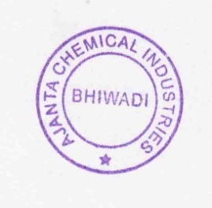
Shelf Life : 3 Years
Storage Condition: Dry and cool place, avoid sun light & moisture
Note: Above Specification As Per EU Regulations No: 231/2012

