**COLOUR SPECIFICATION “AMARANTH”**

EEC No. : E123

C.I. Name : Food Red 9

C.I. No. : 16185

Synonyms : Food Red 9

Einecs : 213-022-2

CAS No. : 915-67-3

Chemical Formula : C20H11N2Na3O10S3

Chemical Name: TRISODIUM 3-HYDROXY-4-(-4-SUPHO-1, 1 NAPHTHYLOAZO) NAPHTHALENE-2, 7- DISULPHONATE

Physical Appearance : Reddish Brown to Dark Brown Powder

Appearance of the Aqueous Solution : Magenta Red

Wavelength of Max. Absorbance : @520 nm

Absorptivity g.cm / 100ml : 440

Bulk Density (BD) : 60-80g/100ml

Pure Dye Content (On Dry Basis at 105⁰C) : Not less than 87%

Loss on Drying at 135⁰C & Sodium Chloride / Sulfate : Less than 13%

Water Insoluble Matter : Less than 0.2%

Ether Extractable Matter : Less than 0.2%

Subsidiary Colouring Matters : Less than 3%

Organic Compounds other than colouring matters:

4-aminonaphthalene-1-sulfonic acid

3-hydroxynaphthalene-2, 7-disulfonic acid

6-hydroxynaphthalene-2-sulfonic acid : Less than 0.5%

7-hydroxynaphthalene-1, 3-disulfonic acid

7-hydroxynaphthalene-1, 3-6-trisulfonic acid

Unsulfonated Primary Aromatic Amines : Less than 0.01%

Lead (As “Pb”) : Less than 2 PPM

Arsenic (As “As”) : Less than 1 PPM

Mercury (As “Hg”) : Less than 1 PPM

Cadmium (As “Cd”) : Less than 1 PPM

Heavy Metals : Less than 40 PPM

Solubility : Soluble in water, sparingly soluble in ethanol

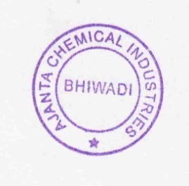Identification of colouring matters : Passes test

Shelf Life : 3 Years

**Storage Condition**: Dry and cool place, avoid sun light & moisture

**Note: Above Specification As Per EU Regulations No: 231/2012**